Design 1

-

Design

3

. Experimental Method and Modelling

Engineering Systems Design 1 – ENG10004

17

/5/

12

**Name**

**Student Number**

Rhys Barnes

910556

Kulunu Dharmakeerthi

Jack Ferry

Prabhjeet Gill

Aneesh Chattaraj

826860

Nikolas Psomoulis

913855



Project

Engineering Systems

Table of Contents

1. Abstract 3

2. Introduction 4

3.Experimental Method and Modelling 5

Tank 5

Pump 7

Wind Turbine 10

Water Disinfection 17

Design Problem 21

Tank Specifications 21

Pump Specifications 23

Pipe Specifications 26

Turbine Specifications 28

CFSTR Operation Specifications 29

Discussion 30

Wind Turbine 30

Pump Design 30

Tank Design 30

CFSTR Design 31

Future Improvements…. 32

6. Conclusion 33

8. References 34

Appendices 34

Figure 9.1: Diagram of experimental setup 35

Figure 9.2: MATLAB coding for Cp(lambda) for the fixed pitch flat blade graph 35

Figure 9.3: MATLAB coding for Cp(lambda, beta) for first plastic contoured blades graph 35

Figure 9.5 Designed tank with inflow and outflow (continuous and strenuous use) 36

Figure 9.6: 9volts vs 6volts dataset 36

Figure 9.7: Height vs Time (theoretical vs dataset) 37

# 1. Abstract

The project aimed to deliver a clean and secure supply of water to a remote community to ease the strain on the already existing means of water supply. The experimental method used involved measuring all required components of calculation in the time provided. These results obtained were a Cp value of 0.079 at λ = 8.06 and ß = 20 degrees. Thus, the pitch angle used in the final blade design was 6.9 degrees. Thus, estimated power production for wind speeds of 3.5 to 17m/s is between 666W and 70.184Kw. Also found were the pipe length which was 55m, with a total height of the water tank from the bottom of the pipe to be 49m., The value of Reynold’s Number was found to be 485393(dimensionless term), with the fanning friction factor (𝑓𝑓) = 0.005 for the proposed pipe design. Total volume of the water tank is 28274 litres. The value of orifice area was found to be .0104m2. It was concluded that the overall water system design would be able to cater for the population which was estimated to reach 2225 at the end of the 10-year time frame in which this system is required to operate.

# 2. Introduction

Worldwide, the need for clean and safe water has increased with challenges posed by developing communities, and other remote regions. The problems facing many of these areas is the need to safely extract, store, treat and deliver water to every required location. Also, it is necessary to form a sustainable solution for these issues in terms of both environmental, yet also structural integrity, whereby rigidity may be challenged due to volatile weather conditions.

Previous work into the appropriate design of such a functioning system have led to the many innovative ways to more effectively and appropriately cater for this need. With the development of wind-turbines, revolutionary materials as well as the upcoming research into the effectiveness of ozone water treatment, a firm foundation upon which sustainable water treatment is present.

In the task posed to Pumps ‘R Us, the project involved planning, modelling, design and testing a small wind-powered pumping station to supply drinking water to a remote community from a well situated underground, for a town of initial population of 2000 people. The project emphasises the need to eliminate the inconvenience of fetching water from a solitary well which caters for such a large population, most of which may be unaware of the risks associated with such an open water source. These risks include, susceptibility to contamination, as well as exposure to elemental factors, whereby volatile weather has the potential to completely restrict access to drinking water if this source is damaged. Thus, this project aimed to construct and maintain a water collection, storage and treatment system, of which it was assumed is completely powered sustainable energy, by means of harnessing the volatile weather conditions and converting air flow to a form of power.

# 3.Experimental Method and Modelling

## Tank

**Experiment:**

The first step in producing this tank, the value of the orifice coefficient was determined. The orifice is exit point for the water from the tank, as the water from the tank is fed through a pipe so it can undergo treatment and be provided to the population of the town. To determine this value a small scaled rig was created, to produce similar conditions and simulations as to what a real-life water pumping system would produce.

In this experiment, the tank was filled with water to the greatest height of the tank, without causing it to overflow. Once the initial height was recorded, increments of 1cm were marked on the side of the tank (refer to figure 1.1 in appendix). This was used during the experiment as once the tap at the bottom of the tank was released, the height of the water slowly decreased. Once the height reached every increment, the time taken to reach that specific increment was recorded. This was completed until the tank had completely drained. The experiment was then repeated twice more, producing the values given in table 1.1.

*Table 1.0: Height vs Time for tank drain*

|  |  |  |  |
| --- | --- | --- | --- |
| **Height (metres)** | **Experiment 1(seconds)** | **Experiment 2 (seconds)** | **Experiment 3 (seconds)** |
| .07 | 51.12 | 52.79 | 41.53 |
| .06 | 52.13 | 52.20 | 40.55 |
| .05 | 51.15 | 50.60 | 42.51 |
| .04 | 53.78 | 52.27 | 45.35 |
| .03 | 54.87 | 48.83 | 40.28 |
| .02 | 55.31 | 51.38 | 41.40 |
| .01 | 57.65 | 58.79 | 48.10 |

Using these values, three graphs were graphed on MATLAB (refer to figure 1.2 in appendix). The most appropriate graph was used to find the Cd value.

*Graph 1.0: MATLAB graph of graining experiment*

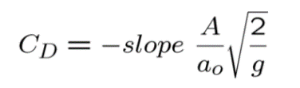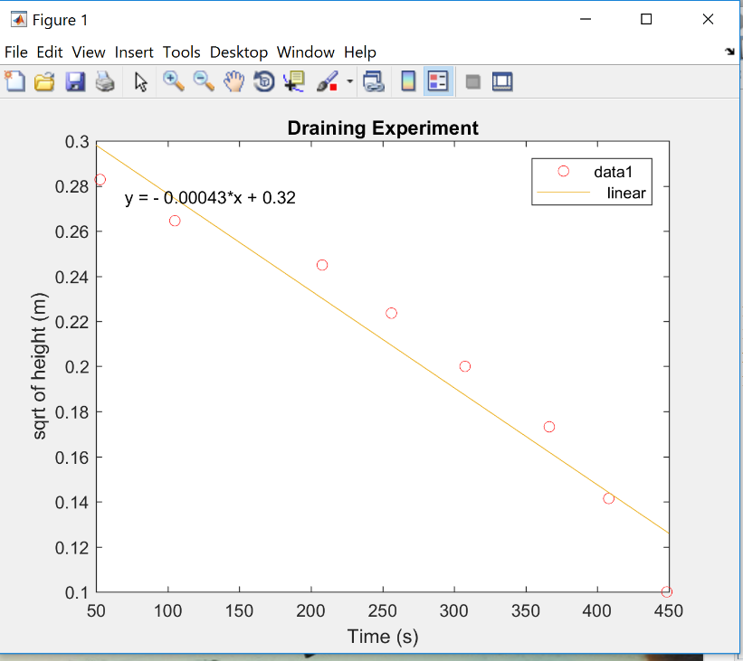

**Slope = .00043**

Using the equation displayed above, the orifice coefficient, Cd, was calculated

**Cd=0.4753**

**Evaluation of experimental procedure**

The value of Cd found was 0.4753. This was logical as a small value indicated that the pipe running from the tank is short and pointed upwards. This was further explained by the decrease in the drainage times as the height of the fluid slowly decreased. This was because of numerous factors: less fluid reduced the impact of gravitational drainage, and more importantly, as the pipe was above the bottom of the tank, the fluid did not completely drain, thus increasing the drainage time.

As the Cd value calculated was very small, the type of pipe consistent with a pipe which is short and pointing upwards. This seems correct, as the pipe used for experiment was pointed upwards. This caused the streams of water used in the experiment to converge in a smaller area. Slowing down the rate at which water escaped the pipe and more importantly reducing the value of the drainage coefficient. This was also exacerbated by the small diameter of the pipe used in the experiment, the small diameter of .002 metres created a greater turbulence between the water, once again reducing the drainage coefficient obtained.

**Improvements to experimental procedure**

* Obtain a larger data set by repeating drainage experiment numerous times. This reduces the impact of measurement errors on the viability of the results

## Pump

Having established the drainage behaviour of the experimental rig in previous workshops, the logical next step was to generate a more complete model of the dynamic tank system; one which demonstrates the influences of both outflow as well as constant inflow. The empirical modelling and data derived through this experiment founded the group’s understanding of pumping mechanisms, and the small-scale valuation of pump flowrate and pressure head became the cornerstone through which the large-scale pumping system was designed.

Experimentation was conducted with the aim of calculating pump flow rate and pressure head, and was grounded on simple mathematical theory.

**Rig Flow Rate**

During workshop sessions, a flow rate was found for a pump powered by 6.0V and 9.0V. The following section provides a brief overview of the conducted experiments and the datasets that were obtained.

**Experiment**

Starting with an empty, closed-off tank (*see appendix: figure 9.8*), a constant inflow of water was introduced, and the increasing height of fluid in the tank was measured over time till the rig reached maximum capacity. Inflow was delivered first by a pump powered at 6.0V, and then repeated with a 9.0V power input.

Several measures were taken to minimise error, and increase the accuracy and reliability of results:

* Water height was measured at the meniscus
* Measuring the water height over constant time intervals was foreseen as a troublesome and possibly an inefficient process for retrieving data. Rather, the inverse process was adopted, and time was measured as the water level increased between consistent increments (constant height intervals). The reason being was that the measurement of time (using a stopwatch) proved to be far easier and less erroneous than the measurement of height (which would have involved painstakingly measuring height over and over using a ruler).
* Experiment was repeated multiple times, each time with a different team member observing water height, and a different member recording time

**Results**

*Table 1.1: Results for pump powered inflow*

|  |  |  |
| --- | --- | --- |
| Height | Time Taken (6v) | Time Taken (9v) |
| 0.01 | 111 | 24.93 |
| 0.02 | 156.6 | 47.53 |
| 0.03 | 211.7 | 74.26 |
| 0.04 | 266.4 | 99.37 |
| 0.05 | 330.4 | 125.66 |
| 0.06 | 419.4 | 154.52 |
| 0.07 | 546.4 | 196.72 |

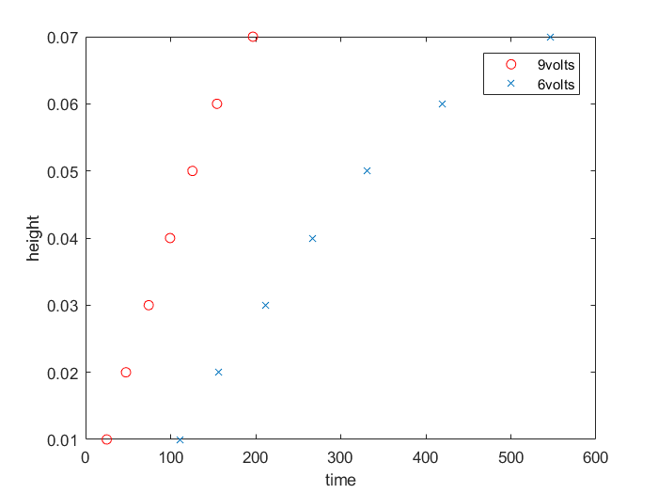

After running the experiment numerous times, the best trials were chosen as a basis for future calculations. The chosen datasets (Height vs Time) were modelled in MATLAB, and an approximated linear relationship between the two variables allowed for the calculation of pump flow rate.

*Graph 1.1: Height versus time for pump driven tank inflow*

Utilising the regression tools available in the MATLAB software, the gradients of the fitted 9V and 6V scatterplots were found. Understanding that a linear approximation of the height vs time data gives an indication of dHdt, the mathematical relationship:

*Equation 1.0: instantaneous change in height over time (only inflow)*

$$A\frac{dH}{dt}=Q$$

was manipulated to identify the pump flow rates.

|  |  |  |
| --- | --- | --- |
| Pump Power | 6 Volts | 9 Volts |
| Flow Rate | 0.000004305 | 0.00001107 |

**Further Experimentation**

While simulating a tank system with only pump powered inflow (no outflow) gave an indication of flow rate and pressure head, it was not sufficient when it came to understanding how a dynamic tank system (with inflow and outflow) would operate. Considering that this is a primary concern for the design project, we thought it best to simulate such a scenario within the small-scale of our experimental rig.

A 9.0 Volt pump was used to provide an adequate inflow, and outflow was driven by gravity. Beyond this, the procedure was identical to the earlier experiment.

**Results**

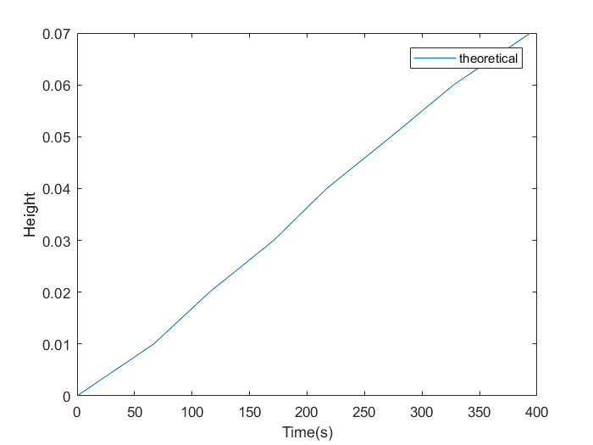

After obtaining suitable values of height versus time, the data was graphed on MATLAB.

*Graph 1.2: Height versus time-theoretical*

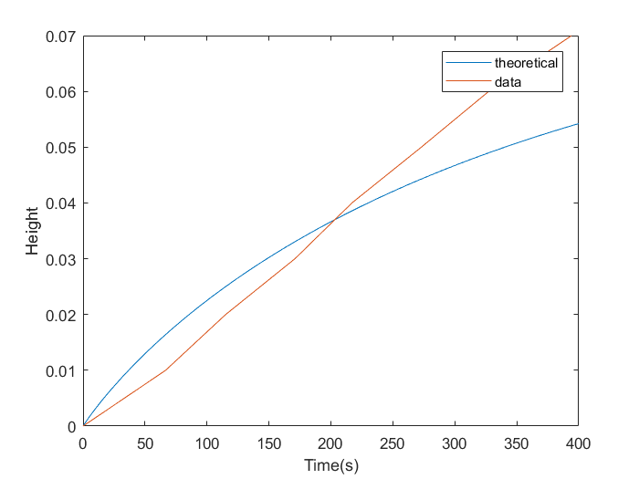

As the data alone fails to give an idea of the accuracy of our experiment, it was exhibited against the theoretical model for the rig system. *The theoretical model is the solution to the ODE: dHdt = Q/A - (a0*Cd*sqrt(2*g*h))/A*

*.*

*Graph 1.3: Height versus time - comparison*

Thus, through comparison of the theoretical graph and data, an understanding of a tank system experiencing both inflow and outflow was gained, and extrapolating from these findings helped in the large-scale design project.

**Pump Pressure Head**

To calculate the pump pressure head, the same setup as the previous experiment was adopted, only, instead of recording the changes in height, the voltage, current and power of the pump was recorded (this was achieved by connecting the pump control module to an energy monitor). From there, P = Ws pva was manipulated to give a value for Ws (specific work) which indicates pressure head.

|  |  |  |
| --- | --- | --- |
| Power | 9.0 Volts | 6.0 Volts |
| Pressure Head | 250.4 m | 286.4 m |

## Wind Turbine

It is necessary to calculate the maximum Cp (power coefficient) to determine the amount of power that the wind turbine will produce. This will then determine the specifications of the pump as the wind turbine generates the power for the pump. Through this equation,

*Equation 1.1: To determine power*

P (power) = $\frac{Cp\left(λ,ß\right){Vw}^{3}pA}{2}$

the greater the Cp value, the greater amount of power the wind turbine will generate. Therefore, it is required to calculate the absolute maximum Cp value.

The maximum Cp value is expected to be around the region of 0.1 as the highest value Cp can possibly be is 0.59 which is known as Betz’ law. However, the real-world limit for scientifically developed wind turbine blades is between 0.35 and 0.45. (The Royal Academy of Engineering) Therefore, it was decided that the Cp value should be in the region of 0.1 because this wind turbine has not been scientifically developed with the use of a wind tunnel and professionals. Some errors will therefore limit the output of the blades.

**Experiment**

To calculate the maximum Cp value for the wind turbine, some experiments needed to be run on a smaller scale. It was decided to do two experiments, one to plot Cp(λ) and the other to plot Cp(λ,β).

The first experiment was set up as in the diagram in figure 9.1. In this experiment, a plastic flat blade was used as a control, and ß (pitch angle) was kept at a constant 10 degrees. This was so the relationship between Cp and λ (tip-speed ratio) could be inspected and noted. The energy meter was then used to measure the RPM (revolutions per minute) and the power, while also using the anemometer to calculate Vw (wind speed). After these values were measured, the experimenters could then calculate λ, ω (angular velocity) and ultimately the Cp value by plotting Cp(λ). These values were calculated from the equations:

*Equation 1.2: Area*

$$A=πr^{2}$$

*Equation 1.3: Angular velocity*

ω = $\frac{2π}{60} ×RPM$

*Equation 1.4:*

λ= $\frac{ωr}{v}$

*Equation 1.5: To calculate Cp values*

Cp = $\frac{2P}{v^{3}pA}$

where r=0.18m and p=1.225kg/m.

In the second experiment, the first experiment was repeated however a few of the constants were changed. Instead of using a plastic flat blade, a cardboard flat blade was used, to see whether the initial specifications for the custom blades, including length and width, would return a higher Cp. This meant that r for this experiment was now 0.177m. ß was also changed from being a controlled, to the independent variable to see the link between Cp, λ and ß. Thus, the experiment was setup again like in figure 1 and the same method was repeated like that in the first experiment. The experiment finished by plotting Cp(λ, β) and calculated the maximum Cp value from that. (See figure 9.11)

However, it was thought that cardboard was not a suitable material for wind turbine blades which is supported by the ‘Cp(lambda, beta) for cardboard blades’ graph because the maximum Cp value is significantly smaller than 0.1, and the plans for the final custom blades included a contoured profile, rather than a flat one. The second experiment was therefore conducted again, however with the first iteration of the plastic contoured blades. The second attempt at experiment 2 was named ‘Cp(λ,ß) for first plastic contoured blades’. (See figure 9.12)

This blade was initially modelled in Sketch up. This 3D modelling program provided a simpler and easier way to model the blades to the desired specifications than other 3D modelling programs such as FreeCAD and Autodesk which both encompassed steep learning curves, proving hard to be overcome with lessons due to time and class clashes. Opting to use this program however had some limitations, including the inability to create aero foil like rounded shapes and to export the model directly into the format required by the 3D printer. Thus, the file was exported into FreeCAD wherein the file type was changed into one accepted by the 3D printer. This process could be improved with more consultation/lessons in how to model 3D designs in a wide variety of programs outside of the designated lessons, externally or by more members of the group so limitations by software do not affect the outcome of the model.

As the initial 3D blades produced a Cp value much lower than 0.1, more time and research was devoted in improving the design and shape of the blades, using an equation to model the surface of the blades in a program which allowed this: AutoCAD. The specifications used for the design of the blade were based off the National Renewable Energy Laboratory’s S825 Turbine blade design (See appendix 1.3). This third experiment was called ‘Cp(λ,ß) for final plastic contoured blades’ and returned a maximum Cp value of 0.079, the closest value recorded to the goal of 0.1. Thus, the settings of ß = 20˚ and λ = 8.058375 were used as the ideal specifications for the turbine. (See figure 9.13)

**Results**

*Table 1.2: Results for experiment 1*

|  |  |  |  |  |  |
| --- | --- | --- | --- | --- | --- |
| **ω (rad/s)** | **RPM** | **P (watts)** | **V (m/s)** **wind** | **λ** | **Cp** |
| 20.95 | 200 | 0.033 | 2.5 | 1.508 | 0.0338 |
| 29.32 | 280 | 0.012 | 3 | 1.759 | 0.00711 |
| 34.55 | 330 | 0.022 | 3.5 | 1.777 | 0.00821 |
| 64.30 | 614 | 0.077 | 4 | 2.894 | 0.0193 |
| 54.45 | 520 | 0.051 | 4.5 | 2.178 | 0.00896 |
| 86.10 | 855 | 0.102 | 5 | 3.100 | 0.0131 |

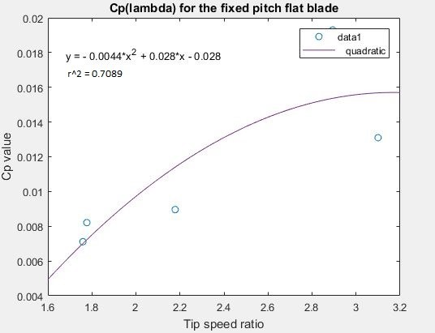*Graph 1.4: Cp(λ) for fixed pitch flat blade*

figure 9.2: MATLAB coding for Cp(lambda) for the fixed pitch flat blade graph

By fitting a quadratic trendline to the graph, the maximum Cp value can be determined by using calculus. If y = -0.0044*x^2 + 0.028*x – 0.028  
then, $\frac{dy}{dx}$ = 0.028 – 0.0088*x  
and maximum Cp occurs at $\frac{dy}{dx}$ = 0,  
So, 0.028 – 0.0088*x = 0  
maximum y = 0.01655 at x = 3.182  
Therefore maximum Cp is 0.01655 when λ = 3.182

A quadratic trendline was used as the Melbourne School of Engineering implied that a quadratic trendline should be used to find the maximum Cp value. (Melbourne School of Engineering)

*Table 1.3: Experiment 2*:

|  |  |  |  |  |  |  |
| --- | --- | --- | --- | --- | --- | --- |
| **Angle (degrees)** | **Velocity (m/s)** | **RPM** | **Power (W)** | **Angular velocity** ꙍ (rad/s) | **Lambda (**λ) | **Cp** |
| 10 | 4 | 320 | 0.028 | 33.50 | 1.48 | 0.00726 |
| 10 | 4.5 | 440 | 0.036 | 46.1 | 1.81 | 0.00655 |
| 10 | 5 | 800 | 0.075 | 83.77 | 2.97 | 0.00995 |
| 15 | 4 | 420 | 0.011 | 43.98 | 1.95 | 0.00285 |
| 15 | 4.5 | 850 | 0.125 | 89.01 | 3.50 | 0.0228 |
| 15 | 5 | 900 | 0.210 | 94.25 | 3.34 | 0.0279 |
| 20 | 4 | 550 | 0.075 | 57.6 | 2.55 | 0.0194 |
| 20 | 4.5 | 620 | 0.097 | 64.93 | 2.56 | 0.0177 |
| 20 | 5 | 850 | 0.192 | 89.01 | 3.15 | 0.0255 |
| 30 | 4 | 520 | 0.050 | 54.45 | 2.41 | 0.0130 |
| 30 | 4.5 | 600 | 0.067 | 62.83 | 2.47 | 0.0122 |
| 30 | 5 | 900 | 0.160 | 94.24 | 3.34 | 0.0212 |
| 35 | 4 | 390 | 0.022 | 40.84 | 1.81 | 0.00570 |
| 35 | 4.5 | 450 | 0.040 | 47.12 | 1.85 | 0.00728 |
| 35 | 5 | 500 | 0.050 | 52.36 | 1.85 | 0.00664 |

*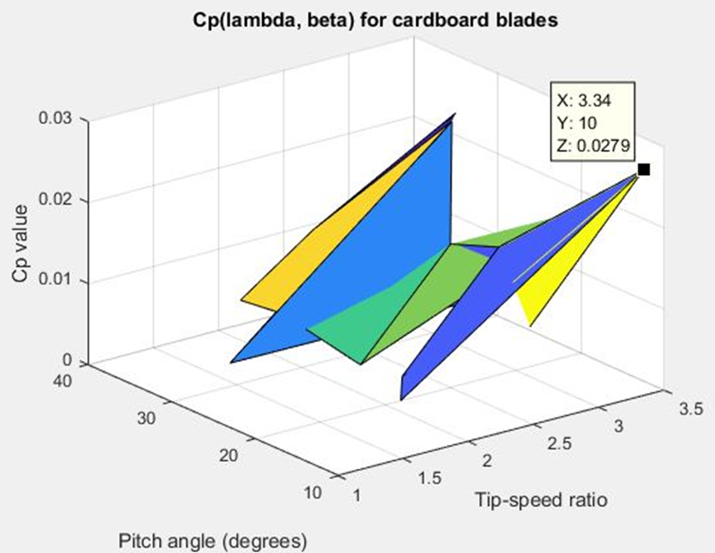Graph 1.5: Cp(λ) for fixed pitch flat blade*

figure 9.3: MATLAB coding for Cp(lambda, beta) for cardboard blades graph

By simply using the data cursor tool on MATLAB, the maximum Cp value was 0.0279 at λ = 3.34 and ß = 10 degrees.

*Table 1.4.: Cp(λ,ß) for cardboard blades*

|  |  |  |  |  |  |  |
| --- | --- | --- | --- | --- | --- | --- |
| **Angle (degrees)** | **Velocity (m/s)** | **RPM** | **Power (W)** | **Angle of velocity (**ꙍ) | **Lambda (**λ) | **Cp** |
| 10 | 3 | 320 | 0.004 | 17.12 | 1.084266667 | 0.00213 |
| 10 | 3.5 | 450 | 0.036 | 47.12 | 2.557942857 | 0.0121 |
| 10 | 4 | 620 | 0.072 | 64.92 | 3.0837 | 0.0162 |
| 15 | 3 | 78 | 0 | 8.17 | 0.517433333 | 0 |
| 15 | 3.5 | 250 | 0 | 26.18 | 1.4212 | 0 |
| 15 | 4 | 390 | 0.032 | 40.84 | 1.9399 | 0.0072 |
| 20 | 3 | 350 | 0 | 36.65 | 2.321166667 | 0 |
| 20 | 3.5 | 430 | 0.034 | 45.03 | 2.444485714 | 0.0114 |
| 20 | 4 | 810 | 0.127 | 84.82 | 4.02895 | 0.0286 |
| 30 | 3 | 300 | 0.004 | 31.42 | 1.989933333 | 0.00213 |
| 30 | 3.5 | 300 | 0.012 | 31.42 | 1.705657143 | 0.00403 |
| 30 | 4 | 810 | 0.07 | 84.82 | 4.02895 | 0.0157 |
| 35 | 3 | 220 | 0.003 | 23.04 | 1.4592 | 0.0016 |
| 35 | 3.5 | 260 | 0.011 | 27.22 | 1.477657143 | 0.00369 |
| 35 | 4 | 390 | 0.035 | 40.84 | 1.9399 | 0.00787 |

*Graph 1.6: Cp(* *λ,ß) for first plastic blades*

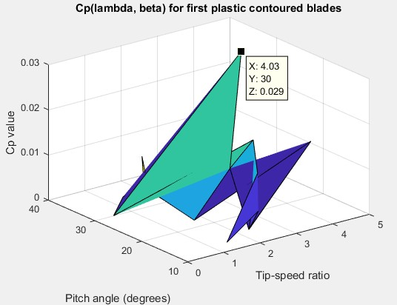

figure 9.31: MATLAB coding for Cp(lambda, beta) for first plastic contoured blades graph

By using the data cursor tool on MATLAB, the maximum Cp value is 0.029 at λ = 4.03 and ß = 20 degrees

*Table 1.5: Cp(λ,ß) for first plastic contoured blades*

|  |  |  |  |  |  |  |
| --- | --- | --- | --- | --- | --- | --- |
| **Angle (degrees)** | **Velocity (m/s)** | **RPM** | **Power (W)** | **Angular velocity (**ꙍ) | **Lambda (**λ) | **Cp** |
| 10 | 3 | 240 | 0.01 | 25.13 | 1.59156667 | 0.00398 |
| 10 | 3.5 | 490 | 0.072 | 51.31 | 2.7854 | 0.018 |
| 10 | 4 | 800 | 0.21 | 83.78 | 3.97955 | 0.0352 |
| 15 | 3 | 110 | 0.006 | 11.52 | 0.7296 | 0.00239 |
| 15 | 3.5 | 360 | 0.029 | 37.7 | 2.04657143 | 0.00723 |
| 15 | 4 | 760 | 0.11 | 79.59 | 3.780525 | 0.0185 |
| 20 | 3 | 350 | 0.027 | 36.65 | 2.32116667 | 0.0107 |
| 20 | 3.5 | 690 | 0.11 | 72.26 | 3.92268574 | 0.0275 |
| 20 | 4 | 1620 | 0.471 | 169.65 | 8.058375 | 0.079 |
| 30 | 3 | 300 | 0.018 | 31.42 | 1.9899333 | 0.00716 |
| 30 | 3.5 | 540 | 0.08 | 56.55 | 3.06985714 | 0.02 |
| 30 | 4 | 820 | 0.31 | 85.87 | 4.078825 | 0.052 |
| 35 | 3 | 220 | 0.011 | 23.04 | 1.4592 | 0.00437 |
| 35 | 3.5 | 420 | 0.04 | 43.98 | 2.38748571 | 0.01 |
| 35 | 4 | 760 | 0.21 | 79.59 | 3.780525 | 0.0352 |

*Graph 1.7: Cp(* *λ,ß) for final plastic blades*

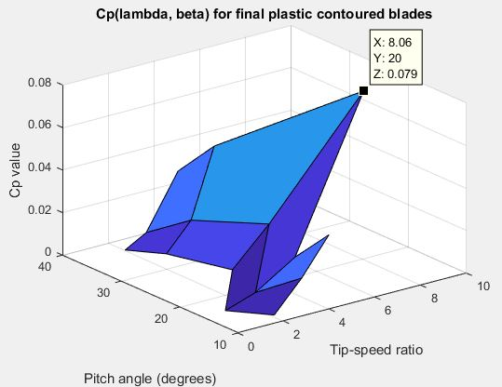 figure 9.32: MATLAB coding for Cp(lambda, beta) for final plastic contoured blades graph

By again simply using the data cursor tool on MATLAB, the maximum Cp value is 0.079 at λ = 8.06 and ß = 20 degrees

**Evaluation of experimental procedure**

By looking at the first experiment, it can be concluded that for a blade with a fixed pitch angle of 10 degrees, a λ of 3.182 is desirable for a maximum Cp value of around 0.01655. However, to obtain a greater Cp value, ß must be varied; so this experiment only finds a relationship between Cp and λ. Therefore, this experiment must be ignored when trying to figure out the maximum Cp value and at what λ and ß it occurs at.

However, the first attempt at the second experiment reveals that the ideal Cp was 0.0279 at λ = 3.34 and ß = 10 degrees. But because 0.0279 is much lower than the anticipated 0.1, it was decided to redo the second experiment but this time use a stronger material for the blades and contour the blades to increase lift and decrease drag.   
The second attempt of the second experiment highlights that the maximum Cp value is 0.029 when λ = 4.03 and ß = 20 degrees. Unfortunately, 0.029 is only slightly bigger than 0.0279, so the second experiment will need to be repeated for a third time, but this time use blades with more thickness and width to improve the lift even more than it was previously.

After adjusting the blades, developing them with more thickness and more profile, the third attempt at the second experiment was completed. The wind turbine produced a maximum Cp value of 0.079 where λ = 8.06 and ß = 20 degrees. Even though this was still slightly below 0.1, this was the closest value we recorded to 0.1. Accounting for errors, such as the roughness of the blade, increasing friction with the air, and subsequently decreasing the Cp value, due to the nature of the 3D printing material, the Cp value of 0.079 was determined to be our optimum Cp value. This blade design with these settings was chosen as the final design for the turbine blades.

## Water Disinfection

The ozone decay rate constants and pathogen inactivation rate constants were determined using the following formulas in Excel:

*Equation 1.6: Log inactivation table*

$$\log_{10}\left(\frac{N_{0}}{N}\right)= k_{p}*C*T$$

Where:

N – Number of organisms that remain viable

N0 – Initial number of viable organisms

kp– Pathogen inactivation rate constant (L/mg-min)

C – Residual in water concentration of the disinfectant (mg/L)

T - exposure time (minutes)

Log10 (N0/N) - log-inactivation credit

To successfully find the log inactivation credits for both Giardia and Viruses, the other variables in equation 1.1 had to be determined first.

**I. Residence Time:**

*Equation 1.7: Residence Time*

$$θ =\frac{V}{q}$$

Where:

θ - Residence time (minutes)

V - Volume (Litres)

q - Flow rate (L/min)

Thus, where the volume was selected to be 250L and the flow rate to be 20 L/min:

$$θ =\frac{250}{20}=12.5 minutes$$

**II. Inactivation rate constant**

The inactivation rate constant, Kp, is specific to a pathogen and has units of (L/mg-min) for reacting with ozone is given by (from the EPA handbook reference in design project):

Equation 1.8 – Inactivation rate constant for Giardia (Kg)

Giardia: $k_{g}=1.0380{*\left(1.0741\right)}^{Temp}$

Viruses: $k_{v}=2.1744{*\left(1.0726\right)}^{Temp}$

Equation 1.9 – Inactivation constant for Viruses (K­v)

Thus, using the found values, the log inactivation credits at 20°C, were calculated:

$$k_{g}=1.0380{\left(1.0741\right)}^{20}=4.336$$

$$k_{v}=2.1744{\left(1.0726\right)}^{20}=8.833$$

**III. Reaction constant (k) (min-1)**

To find the reaction constant (k) in units of min-1, the following formula was used:

*Equation 1.10: Reaction constant*

$$\ln{\frac{c_{A}\left(t\right)}{c_{A0}}}= -kt$$

Where:

cA(t) – Concentration at time (mg/L)

cA0 – Initial concentration (mg/L)

k – reaction rate (min­-1)

t – time elapsed (min)

Thus, given the half-lives at various temperatures, we could calculate the reaction rate in

min-1. The half-life of the pathogens at 20°C, was 19 min. Due to the half-life representing exactly half the concentration, the ratio cA(t)/ cA0 was equated to 0.5.

Solving for k, gave:

$$k=\frac{\ln{0.5}}{19}=0.036481 \sim 0.0365/min$$

**IV. Residual in water concentration of the disinfectant (mg/L)**

*Equation 1.11: Residual in water concentration*

$$c_{A}= \frac{qc_{Af}}{(q+kV)}$$

Where:

cA - Residual in water concentration of the disinfectant (mg/L)

q - Flow rate (L/min)

cAf - Inlet concentration (mg/L) – this value was set to 0.11mg/L as part of an assumption provided by the design project constraints

k - reaction constant (min-1)

V - Volume of CFSTR (Litres)

$$c_{A}= \frac{20*0.11}{(20+0.036481*250)}=0.075549 \sim 0.0755mg/L$$

**V. Log inactivation credits**

Thus, the log inactivation credits were found by substituting the values found into the equation 1.1.

$$\log_{10}\left(\frac{N_{0}}{N}\right)= k_{p}*C*T$$

For Giardia, Subbing:

Kp  = Kg =

C = cA=

T = $θ$ = 12.5 minutes

Gave:

$$\log_{10}\left(\frac{N_{0}}{N}\right)= 4.336*0.0755*12.5=4.0921 \sim 4.09$$

For Viruses, Subbing:

Kp  = Kv =

C = cA=

T = $θ$ = 12.5 minutes

Gave:

$$\log_{10}\left(\frac{N_{0}}{N}\right)= 8.833*0.0755*12.5=8.3361 \sim 8.34$$

|  |  |  |  |  |  |  |  |  |  |  |
| --- | --- | --- | --- | --- | --- | --- | --- | --- | --- | --- |
| **Flow Rate q (L/min)** | **Volume of CFSTR (L)** | **Residence Time θ (min)** | **Temperature (°C)** | **Half Life (min)** | **K** | **Kg** | **Kv** | **Ca** | **Giardia log inactivation credits** | **Viruses log inactivation credits** |
| 20 | 250 | 12.5 | 20 | 19 | $$0.0365$$ | $$4.336$$ | $$8.833$$ | $$0.0755$$ | $$4.09$$ | $$8.34$$ |

**Results**

*Figure 3.0 – Key values used for design project with chosen temperature of 20°C.*

# 4.Design Problem

## Tank Specifications

**Water Requirements and Tank Size**

The aim of this project is to provide a water pumping system for an isolated town with a population of 2000 people. The population is estimated to grow by 1.2% annually. As the tank must last a minimum of 10 years, the growth of the population is given by;

*Equation 2.0: To calculate expected population growth*

$$P=2000e^{0.12t}$$

***Note:*** **‘t’ is time in years**

By substituting the value of 10 into ‘t’, we are given the size of population in 10 years which is 2225 people. The average drinking amount recommended for a person is 2.2 litres by the Institute of Medicine in the USA. Hence the minimum volume of the tank is given by:

**2225 people x 2.2 litres = 4895 litres.**

**Considerations:**

When constructing the water tank the weather conditions had to be taken into consideration. The average temperature through the year is 31 degrees Celsius. With this relatively warm temperature we expected the water usage to be a fraction greater than the average drinking amount of 2.2 litres. However, the greatest cause for concern is the town’s vulnerability to cyclones. It was decided that the tank’s volume must be increased drastically in order to provide reserve water for the town in case of an emergency. It was decided that four days of reserve water should be a substantial amount of fresh water for the town, providing adequate time for help to arrive. By providing four days of water, the volume of the tank must be increased by a factor of 4.

**4 x 4895 litres = 19580 litres.**

The reserve water required along with the daily amount would increase the total volume of the tank to 24475 litres.

Radius = 1.5 metres

Height = 4 metres

Volume:

y

*Diagram 2.0*

**Sensors:**

The upper sensor will be placed at a height of 3.3 metres, by doing so the capacity of the tank will be reduced to 23336 litres, which is more than the daily required amount. Also by placing the upper sensor at a height of 3.3 metres, this will provide enough space to prevent the tank from overflowing. If the sensor were to be placed at a height of 3.9 metres, it would be a major risk, as failure from the sensor would cause immediate flooding. More importantly the lower sensor will be placed at a height of 0.7 metres. By placing the lower sensor at this height, the minimum volume of water the tank can hold is 4950 litres. This is critical due to the fact if the sensor is placed at a lower height, it will not provide enough water for the town to survive daily.

**Materials:**

We have decided to make the tank out of aqua plate steel. This material was used for a variety of reasons. Steel is a very strong material in contrast to other materials such as poly-ethylene, this would allow it to withstand extreme weather conditions such as cyclones, protecting the town’s water supplies during potential emergencies such as cyclones. It is also relatively cheap to build in comparison to other materials such as stainless steel. The cost of building an aqua plate steel tank is almost $8000 cheaper; something which would make it economically viable for a small town. Even though the steel could corrode, it unlikely that it will corrode within the next 10 years, preventing pollution of the water supplies in any way.

**Safety Mechanisms:**

The tank being constructed includes a variety of safety features. Firstly, there is an extra sensor placed at a height of 3.9 metres. This would prevent overflowing which is crucial due to the fact there a variety of electrical systems in the tank, as a potential fire could be sparked. Other safety features include an earth wire. Considering the tank is made of steel, a strong conductor of electricity, and that the town is vulnerable to cyclones, a potential lightning strike could occur. If it were to hit the steel tank, an earth wire could transfer the extra electricity into the ground, ensuring that the electrical system does not overheat.

**Orifice Area**

Our orifice is circular, and has an area of 0.0104m2. The calculation behind this involved working with the drainage time equation.

*Equation 2.1: drainage time*

$$t_{drain}=\frac{A}{a_{o}}\sqrt{\begin{aligned}\frac{2H\left(0\right)}{g}\end{aligned}}$$

Constrained by the following:

* Outflow that is too rapid would prove to be detrimental as pump would require more power to be able to provide a sufficient inflow
* Outflow that is too slow would not satisfy the constraints of the reactor component (requires a flow rate greater than or equal to 20L/min)

It was suggested then, that a reasonable time for the tank to drain from full capacity (top sensor- to bottom sensor), was 5 minutes.

Drainage time equation was used to find the necessary orifice area: 0.0104m2.

## Pump Specifications

**Considerations**

Several assumptions were made prior to the pump design

* The tank should be able to fill rapidly despite strenuous and continuous use-capable of filling with 4 days’ worth of water
* Cyclone area
* Water requirements of community: as touched on earlier (approximately 4000 Litres per day)

**Relevant Design Factors**

Contextual information (location, weather, population) had to be considered before work on the real-world design could commence. Although most considerations were not directly applicable to the design of the pump, the interconnectedness of the system inevitably leads to the design of the pump being influenced by external factors impacting on other components of the design. Some considerations:

* Tank dimensions, which are determined by population size and requirements, play a vital role in the determination of a suitable pump flow rate
* The power output of the wind turbine restricts flow rate, and obviously, pump power
* The region is prone to cyclones. The tank must be capable of filling at a rapid rate to allow for intensive use in disastrous situations.
* Outflow of tank must be higher than or equal to inflow rate of reactor component (20L/min)

**Pump Flow Rate**

The first step in the design of this component was determining a suitable pump flow rate.

Doing this involved manipulating the differential equation for a tank with inflow and outflow.

*Equation 2.2: inflow and outflow differential*

$$\frac{dH}{dt}=\frac{Q}{A}-\frac{a_{o}\sqrt{2gH\left(t\right)}}{A}$$

The general solution for the equilibrium position of this ODE was found, and then relevant contextual information was brought in to decide on a suitable equilibrium value (the near constant water height that is approached over time). A height of 3.3m was chosen for the following reasons:

* Tank (4m tall) will not overflow
* Top sensor is located in this area: water level is capable of resting at maximum possible height without use of sensor, and thus a lower use of power.

Substituting the value of 3.3m into the ODE, and considering the orifice area and coefficient, the pump flow rate was found to be **0.0669m3/s**.

The theorised tank system was modelled in MATLAB, producing the following graph:

*Graph 2.0: Model of designed tank system*

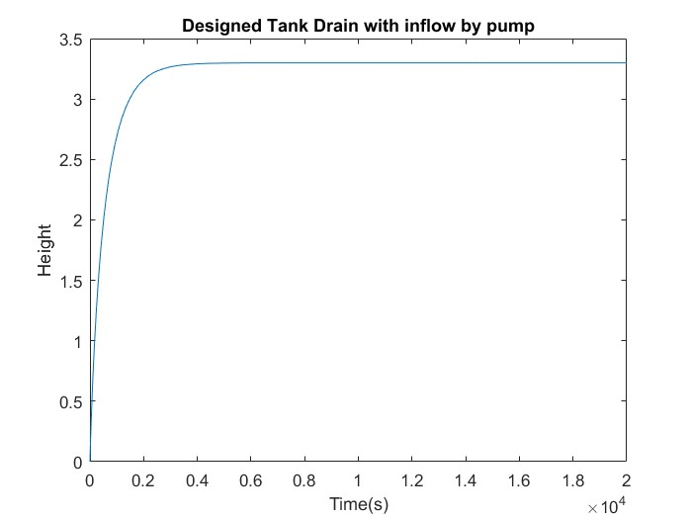

**Pressure head**

Calculation of pressure head involved working closely with the Engineering Bernoulli Equation, and applying it to the pipe system (see section: Pipe Specifications)

*Equation 2.3: Engineering Bernoulli Equation*

**v1=v2**

**p1=p2**

**h1=0m, h2=49m**

**lv=12.83**

Substituting these values in and solving for Ws gives:

**Ws=50.3g**

Therefore, the necessary pressure head was found to be 50.3m.

**Pump Power**

Upon calculating the pressure head (50.3m), and knowing the flow rate as 0.0669m3­/s, a pump capable of producing such values was found.

Below is the pump performance curve of the Griswold R6EM centrifugal pump. As can be seen below, a flow rate of 0.0669m­3/s (1057 gallons/min) and a pressure head of 50.3m (165 feet) was possible.

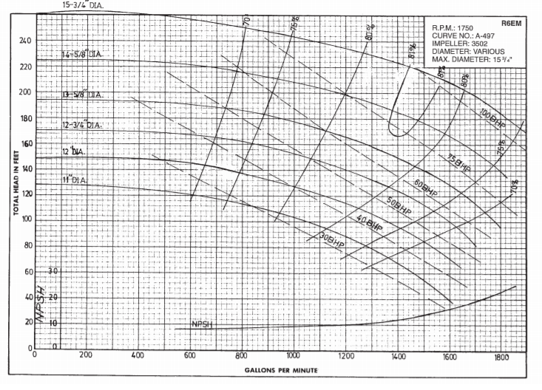

*Figure 3.1: Performance curve for Griswold R6EM*

Utilising the curve, the R6EM model with an impeller diameter of 34.6cm (13-5/8”) seemed a suitable fit. This pump will consume 50BHP🡪37.4kW.

Pump Power: 37.4kW

## Pipe Specifications

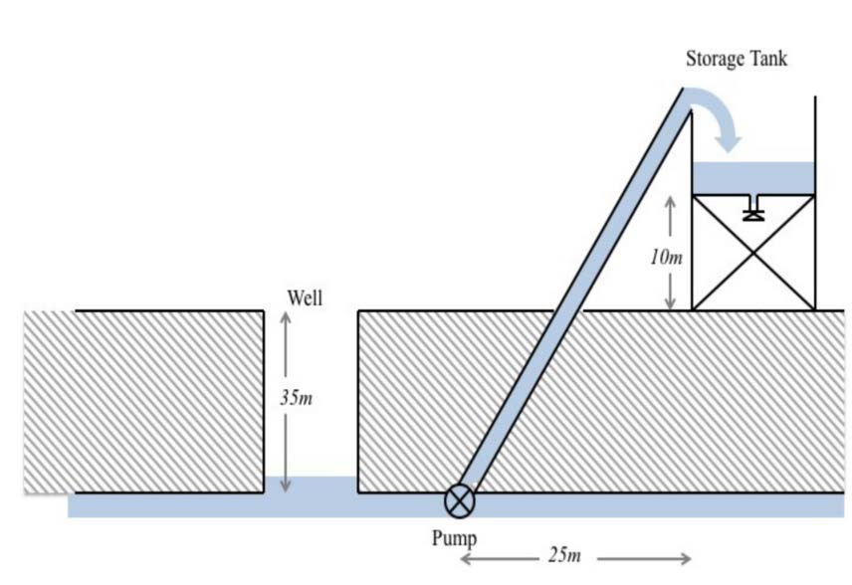Height of tank = 4m

Height of tank above ground +

Height of well below the surface = 10m + 35m= 45m

Total Height = 4m + 45m = 49m

Distance of tank from the well =

25m

Using Pythagoras’ theorem we get the length of the pipe to be 55m which connects directly to the top of the tank.

*Figure 1.1* Length of pipe = √252 + 492 =55m approx.

*Diagram 2.1: design project*

The velocity of water in pipe is 2.16m/s which has been calculated by the help of the formula v=Q/A, where Q is the calculated flow rate from the workshops and A is the area of the pipe.

**Specifications**

The underground pump must pump clean water from 35m underground well into an aboveground tank which is 10m above ground. Therefore

* Length of the pipe is 55m
* Diameter of 0.2m
* Cross sectional area of 0.031m²

As it is known liquids behave differently in pipe flow, they could have laminar flow or turbulent flow. This property of pipe flow is determined with the help of Reynold’s *number* which is calculated by the help of this formula:

*Equation 2.4: Engineering Bernoulli Equation*

$$Re=\frac{ρνd}{u}$$

*-*𝜌 *density (kg/m³)*

*-*𝑣 *velocity (m/s)*

*-d diameter of pipe(m)*

*-u* viscosity of the fluid (Pa.s)

The value of Re the team calculated is **485393**

There are conditions to determine if the flow is turbulent or laminar relating to Reynold’s number*.*

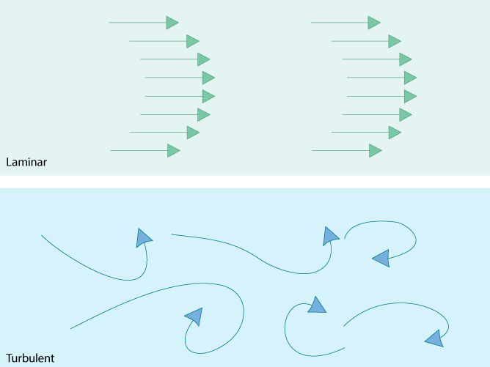Re << 2000 – Laminar (smooth directional flow)

Re >> 2000 – Turbulent (complex flow due to eddies)

Since calculated Reynolds number is much higher than 2000 the flow of water in pipe is turbulent. Attempts at making the flow laminar proved unsuccessful-for flow to be laminar, needed an unreasonable pipe diameter of 56m.

*Figure 3.6*

The pipe is made of concrete and hence it offers friction with the flowing water in the pipe. Friction causes energy loss and affects the pressure and velocity of water in the pipe. The friction is characterised by *Fanning friction factor*.

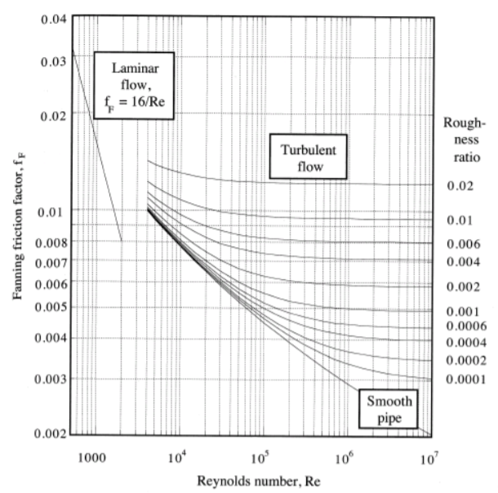

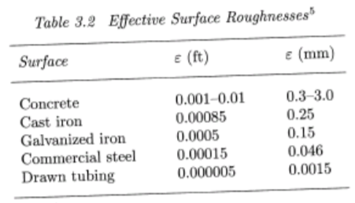

Therefore: 𝑓𝑓=0.005 for the proposed pipe design.

## Turbine Specifications

The equations which correlate to the power output of the blade as well as some real-world turbine designs were the main aspects considered in the design of the custom turbine blades. From the power coefficient, (an aspect having an immense impact on the total power output) it was noted (see below) that the main variables affecting the power output were the tip speed ratio (lambda) and the pitch angle (beta). Thus, these values were the two main values considered when coming up with the desired specifications for the custom designed blades as most blades researched had a similar aero foil or triangular shape.

As the equation shows, the Cp value is related to the rotational speed in m/s times the radius of the turbine in m, divided by the wind speed. With the wind speed an unknown value, and in many ways, the rotational speed dependent on other factors, the radius of the blade was the main specification that was considered and altered. With the results from the first lab experiment, the highest Cp value was 0.01655 which was marginally higher than the Cp value recorded for the highest wind speed and rotational speeds of 5m/s and 86.1rad/s. Thus, upon rearranging the equation to deduce the tip speed ratio, using a slightly faster rotational speed to account for the higher Cp value, but the same wind speed, the ideal length of the blade was calculated to be just under 18cm in length. The actual 3D modelled blade design was 16 cm in length, which is a similar length to what is required for the maximum power output whilst not being so long that too many materials were required to lift the turbine an adequate distance off the ground.

The other variable which Cp and thus power output was dependent on was the pitch angle. From in-workshop testing and research out of the lab, it was found that to obtain the highest Cp value, and thus power output, a pitch angle of 10 degrees should have been applied to the blade. Research into the shape of real-world turbine blades showed that most found that most turbines use blades with rounded, aero foil type edges along their given pitch angle. In the 3d modelling stage however, this proved too difficult to model, due to limitations in both the program used and the expertise of those in charge of design. Thus, instead of an aero foil shape along this pitch angle, a straight contour was utilized, more akin to shapes used in earlier blade design. By using an angle of 10 degrees however, the blade failed to print properly as the contour was too fine to be printed by the 3D printer for the thickness required by the connector (0.9mm). Thus, a straight edge was added at the edge of the contoured edge of the blade, 0.4mm thick to account for the 0.2mm printer layer thickness, to ensure the 3D printer could layer the contour correctly. Thus, the pitch angle used in the final blade design was 6.9 degrees, which may have led to a slightly smaller power output than that estimated using the ideal pitch angle.

Min speed (m/s) 3.5

|  |
| --- |
| Cp(λ,β)v3pA  *Power =*  2 |

Max Speed (m/s) 17

Density (Kg/m^3) 1.225

Swept Area (m/s) 804.2477

Power min (W) 666.502

Power (W) 70184.42

|  |  |
| --- | --- |
| Fibre Glass | Carbon Fibre reinforced plastic (CFRP) |
| With the small scale of the project, including a limited population, limited town access and smaller budget, reinforced fibre glass is the preferred material for the blade construction.   * Cheaper at around $3.90 USD/Kg * Same breaking strain at 2.0% * Can’t withstand as much stress before yield at 125 MPa | Although a more reliable, stronger and lighter material would be more applicable to the climate given, where natural disasters and strong wind events are likely, the sheer cost difference does not reflect the benefits of this material as the material is only 0.3 Mg/m3 lighter and has many similar values for coping with stress and strain.   * Lighter at 1.5Mg/m3 * Can withstand more stress before yield at 200 MPa * More expensive at around $110 USD/Kg |

**Materials**

Despite using it in the scaled down experiments, plastic is not an ideal material for the blades. Although cheap and easy to be moulded into the shape, the extremely light weight along coupled with the size of the blades in real life renders plastic unusable as the material for the turbine. Instead, two stronger, more durable materials which are used in blade construction today were considered for the construction material. These materials include:

*Data obtained from Appendix 1.3 (Props, 2003)*

## CFSTR Operation Specifications

The chosen amount of water delivered to the people, considering population growth, was 4800L. The process was chosen to run for a time of 4 hours, or 240 minutes in total each day, with a flow rate of 20 L/min. Thus, the volume of the CFSTR was chosen to be 250 L, with a residence time of 12.5 minutes.

Using the calculated ozone decay first order rate constants over the varying operating temperatures, which are shown in Appendix…. the operational temperature chosen was 20°C. This produced an outlet concentration of 0.075549 mg/L with the log inactivation credits being 4.094792 for Giardia, surpassing the requirement of 3, and for viruses, 8.341253, being much greater than the standard requirement of 4.

## 5.Discussion

### Wind Turbine

**In the Real World**

The modelled blades are at a 1:100 scale, thus when built in real life, the length of each blade would be 16m. The problems associated with the small-scale design of the blades in the 3D modelling and printing process, such as the need to add an edge at the end of the contour and the inability to adopt an aero foil shape are less likely to occur in the scale up of the model. A straight edge of only 0.4mm on a blade of width 0.9m and length 16m would have a negligible effect on the Cp value. Thus, the Cp value calculated in the workshops was used to estimate the power output of the real-life blades. The minimum speed required for the turbine to produce an output power as determined in the experiments was 3.5m/s. From the wind speed data provided in the document “Winddata(3)” provided, the maximum wind speed recorded was 17m/s. Thus, estimate power production for wind speeds of 3.5 to 17m/s is between 666W and 70.184Kw. Although this figure is less than the 100Kw required to power the pump, these estimates are based off the Cp values calculated with blades limited to an angle of 6.7 degrees, rather than the optimal 10 degrees. Thus, with the use of the optimal angle and the pump not being used constantly, rather, power being conserved for later use, the pump is likely to be completely powered by the wind turbine.

### Pump Design

Key values regarding the design of the pump were found:

* Pump Flow Rate: 0.0669
* Pump Power: 100kW (assumed through research)
* Pressure Head: 152.5 m

As seen in graph 9.5 (see Appendix), under strenuous and continuous use, the designed tank manages to fill completely by the 2-hour mark. Thus, providing more than enough water for the next several days. This is particularly important considering how prone this area is to natural disaster (cyclones). Certainly, before a cyclone hits, the water system would be heavily used, as people collect clean water for use in case of emergency, local hospitals, police and other authorities will likely do the same. So, it’s optimal that despite this, the tank is still able to fill up to max capacity within a brief period. What has been modelled is a tank under use in such conditions, and what has been designed is a pump capable of functioning in intense situations.

### Tank Design

When constructing the water tank the weather conditions had to be taken into consideration. The average temperature through the year was 31 degrees Celsius. With this relatively warm temperature we expected the water usage to be a fraction greater than the average drinking amount of 2.2 litres. However, the greatest cause for concern was the town’s vulnerability to cyclones. It was decided that the tank’s volume must be increased drastically to provide reserve water for the town in case of an emergency. It was decided that four days of reserve water should be a substantial amount of fresh water for the town, providing adequate time for help to arrive to provide water to the town. By providing four days of water, the volume of the tank must be increased by 4 x 4895 litres, which would increase the volume of the tank by 19580 litres. Hence the total value of the tank would be increased to 24475 litres.

The value of Cd found was .0104 as found earlier. This was logical as a small value indicated that the pipe running from the tank is short and pointed upwards. This was further explained by the decrease in the drainage times as the height of the fluid slowly decreased. This was as a result of a numerous factors as less fluid reduced the impact of gravitational drainage and more importantly, as the pipe was above the bottom of the tank, the fluid did not completely drain, increasing the drainage time.

### CFSTR Design

The volume of the CFSTR was chosen to be 250L. The chosen material for the CFSTR was stainless steel, with a PTFE fluoropolymer lining. This lining is extremely stable making it very difficult to react. It serves as a very popular choice in industry regarding the use of corrosive materials, by safely containing and distributing highly-aggressive chemical compounds. These compounds indeed include ozone, which is a highly reactive substance.

**The Key Properties of PTFE**

* Chemically Inert – PTFE does not readily react with highly volatile substances, due to its extremely stable chemical structure.
* PTFE resists the most aggressive organic and inorganic chemicals and solvents over a broad temperature range. This includes: Salt solutions, organic and inorganic compounds.
* PTFE has a very low coefficient of friction and for all calculation purposes it can be considered hydraulically smooth.

PTFE has extremely useful thermal properties, with this stability allowing it to withstand temperatures of up to 200°C, and has been experimentally testing under laboratory conditions to exceed this temperature by up to 60°C

## 6.Future Improvements….

**Pump**

In the future, changing the pump system to a variable speed drive pump may be optimal. As it currently stands, the centrifugal pump requires a power input of 38kW to function, and consequently at times where the turbine is not capable of providing this power, pump will presumably stop function. This may be problematic, but looking at the wind data and terrain of the location, is unlikely to be so. Given the expected output of the turbine is 100kW, then the pump should function solely of the wind turbine system in most situations. Of course, this is not always the case, and so another source of power is also necessary. Consequently, what is required is a switching mechanism so the pump can turn to a different source of power when the wind alone, isn’t enough. It would be ideal if this second power source is dynamic; in that it works with the available wind-generated power, and simply adds a little extra (cleaner energy). Further, if the power output is too high, a variable speed drive pump can choose its efficiency- and so use less of the power provided-thereby a more efficient solution.

**Wind Turbine**

Improvements to experimental procedure

Unfortunately, as noticed by the low R^2 value of 0.71 on the ‘Cp(lambda) for fixed pitch flat blade’ graph and the Cp values being lower than 0.1, it is assumed that a few errors were made during the experiment. These errors could have caused inaccuracies when calculating the maximum Cp value which explains why the second experiment needed to be repeated multiple times.

* Firstly, by having other fans in the same room when doing the experiment there could be wind gusts coming from multiple directions, which would result in unreliability in the anemometer when measuring the wind speed. This could be simply fixed by having only one fan in an enclosed room or laboratory.
* Human error when reading the data may have also contributed to discrepancies in the data as different people recorded each result differently. The wind speed could have discrepancies of up to $±1m/s$, the RPM could be incorrect by $±20 revolutions$ and the power could be out by around $±10mW$. Therefore, to improve the accuracy, only one person should be consistently measuring the data or have a program or machine to record the data. This ultimately reduces the fluctuations and improves the measurements.
* Thirdly, the anemometer was only accurate between around 3 – 4.5m/s because it was found that the fan did not go fast enough to make the windspeed faster than 4.5m/s and when it was lower than 3m/s, the wind turbine would not rotate enough to give a reading for RPM and power on the energy meter. This inaccuracy could be improved by using a better fan and by again only using one fan in an enclosed room.
* By using 3D printed plastics of a minimum thickness of 0.2mm, the blades produced were somewhat coarse. Although a rough edge of 0.2mm may not have any impact on the real world blades that are 100 times greater, in the scaled tests, this roughness created friction with the air, causing the blades to move slower and produce a lower Cp value. Thinner 3D material could be used or the blades could be sanded back to minimize this error.
* Finally, in the first experiment, the blades would hit the shaft at very high speed because the wind was pushing the ends of the blades back towards the shaft. This force then slowed the turbine down and caused the RPM and the power to fluctuate more frequently. This can be improved by making the blades thicker and stronger, so they do not bend and hit the shaft in high winds.

By reducing all these inaccuracies, the results could be improved and the power coefficient could be closer to 0.1 for the wind turbine. This would ultimately improve the accuracy of the overall design project.

## 7. Conclusion

These results obtained were:

* Cp value of 0.079 when tip speed ratio is 8.06 and pitch angle is 20 degrees. Thus, the pitch angle used in the final blade design was 6.9 degrees. Thus, estimated power production for wind speeds of 3.5 to 17m/s is between 666W and 70.184Kw. Also found were the
* Pipe length of 55m, with a total height of the water tank from the bottom of the pipe to be 49m. The value of Reynold’s Number was found to be 485393, with the fanning friction factor (𝑓𝑓) = 0.005 for the proposed pipe design.
* Total volume of the water tank is 28274 litres. It was concluded that the overall water system design would be able to cater for the population which was estimated to reach 2225 at the end of the 10-year time frame in which this system is required to operate.
* The chosen amount of water delivered to the people, considering population growth, was 4800L. The process was chosen to run for a time of 4 hours, or 240 minutes in total each day, which is within the constraint of 3 hours or 300 minutes operational time. The flow rate was determined to be 20 L/min, with the volume of the CFSTR was chosen to be 250 L, with a residence time of 12.5 minutes. The design of the CFSTR obeyed the constraints of the project, with the volume being greater than the minimum of 100L, while also the residence time was within reasonable measure, exceeding the minimum of 10 minutes. With the chosen temperature of operation of 20°C, the log inactivation credits for Giardia were 4.094792, which exceeds the requirement of 3. The log inactivation credit for Viruses, was calculated to be 8.341253, which greatly exceeded the design requirement of 4.

## 8. References

* Alta Grey Industries 2015. University of Melbourne Logo. [http://logodatabases.com/university-ofmelbourne-logo.html/university-of-melbourne-logo](http://logodatabases.com/university-of-melbourne-logo.html/university-of-melbourne-logo)
* Griswold Centrifugal Process Pumps | All Pumps. (2017). Allpumps.com.au. Retrieved 2 June 2017, from <https://www.allpumps.com.au/brands/griswold#undefined2>
* Griswold E,F&G Series Performance Curves. (2017) (1st ed.). California. Retrieved from <https://www.allpumps.com.au/assets/pdf/griswold/griswold-e-f-g-performance-curves.pdf>
* Material Compatibility with Ozone. (2017). Ozoneservices.com. Retrieved 30 May 2017, from <http://www.ozoneservices.com/articles/003.htm>
* Melbourne School of Engineering. (n.d.). *System Modelling and Design: Wind Turbine System.* Melbourne. <https://app.lms.unimelb.edu.au/bbcswebdav/pid-5624557-dt-content-rid-21241090_2/courses/ENGR10004_2017_SM1/W05Q%281%29.pdf>
* Mr. Brian Oram, P. (2017). *Ozonation in Water Treatment*. *Water-research.net*. Retrieved 27 May 2017, from <http://www.water-research.net/index.php/ozonation>
* Products), C. (2017). Fluoropolymers | PTFE | PFA | FEP | PVFD | Chemraz | CRP. Crp.co.uk. Retrieved 28 May 2017, from <http://www.crp.co.uk/technical.aspx?page=9>
* Props. (2017) (1st ed.). Boston. Retrieved from <http://web.mit.edu/course/3/3.11/www/modules/props.pdf>
* PTFE, FEP and PFA: What's the difference? - Product Release. (2017). Product Release. Retrieved 29 May 2017, from <http://www.product-release.com/product-release-news/ptfe-fep-pfa-whats-difference/>
* NWTC Information Portal. (2014). S*825 Airfoil Shape*. Retrieved 17 May 2017, from <https://wind.nrel.gov/airfoils/shapes/S825_Shape.html>
* The Royal Academy of Engineering. (n.d.). *Wind Turbine Power Calculations* <http://www.raeng.org.uk/publications/other/23-wind-turbine>

# Appendices

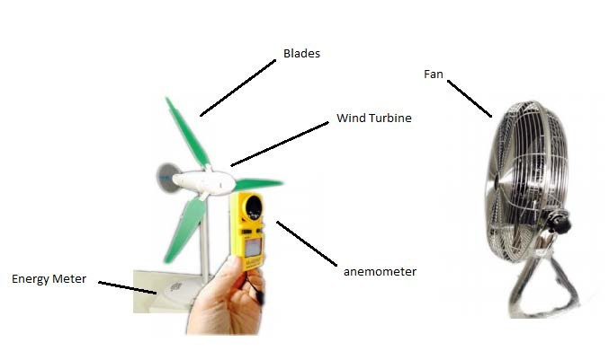

### Figure 9.1: Diagram of experimental setup

### Figure 9.2: MATLAB coding for Cp(lambda) for the fixed pitch flat blade graph

### Figure 9.3: MATLAB coding for Cp(lambda, beta) for cardboard blades graph

*Figure 9.31: MATLAB coding for Cp(lambda, beta) for first plastic contoured blades graph*

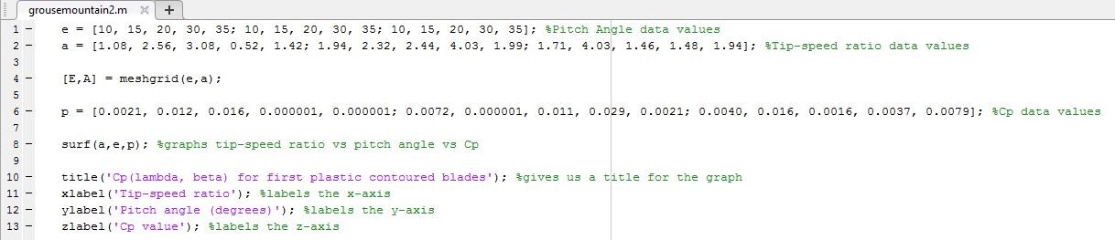

*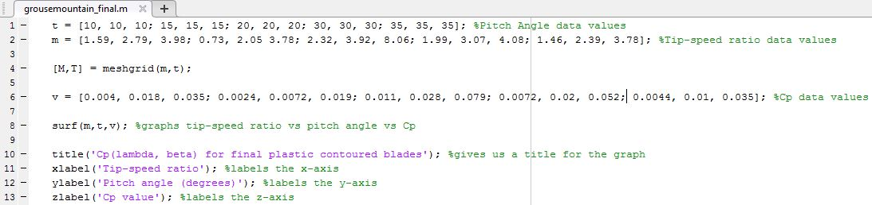 Figure 9.32: MATLAB coding for Cp(lambda, beta) for final plastic contoured blades graph*



### Figure 9.5 Designed tank with inflow and outflow (continuous and strenuous use)

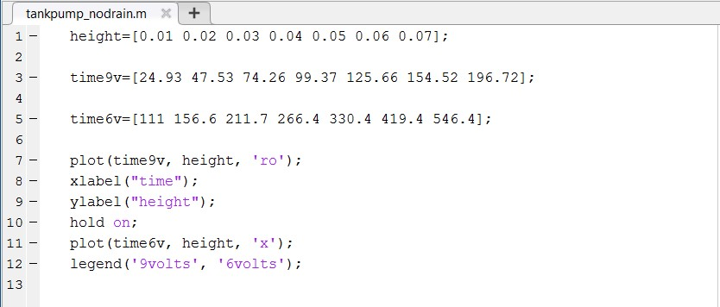

### Figure 9.6: 9volts vs 6volts dataset

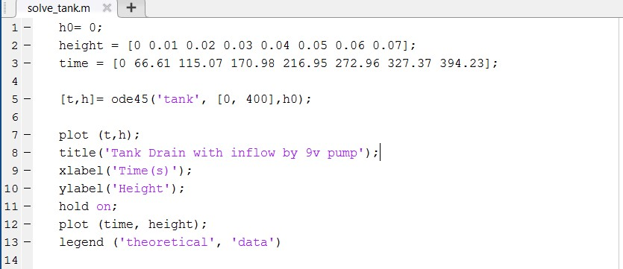

### Figure 9.7: Height vs Time (theoretical vs dataset)

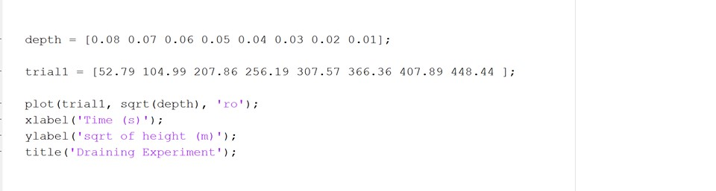

*Figure 9.8: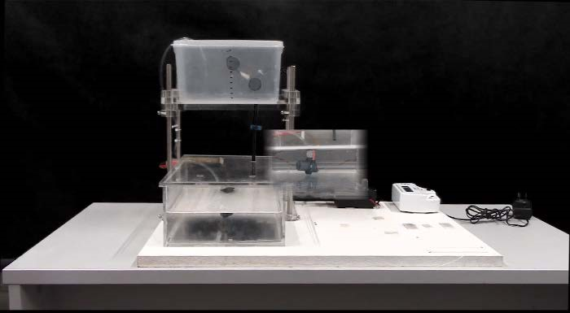This is the rig used for the experiment. The markings on the above tank signify the 1cm increments used for the experiment.*

*Figure 9.9 – Sketchup Blade Design and Blade Length*

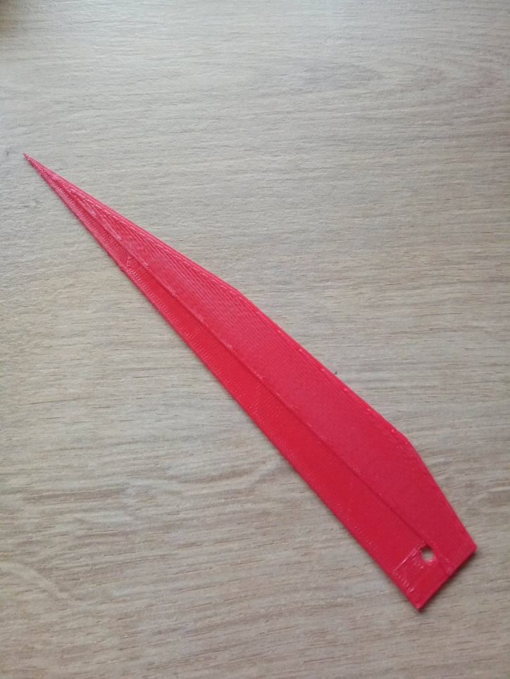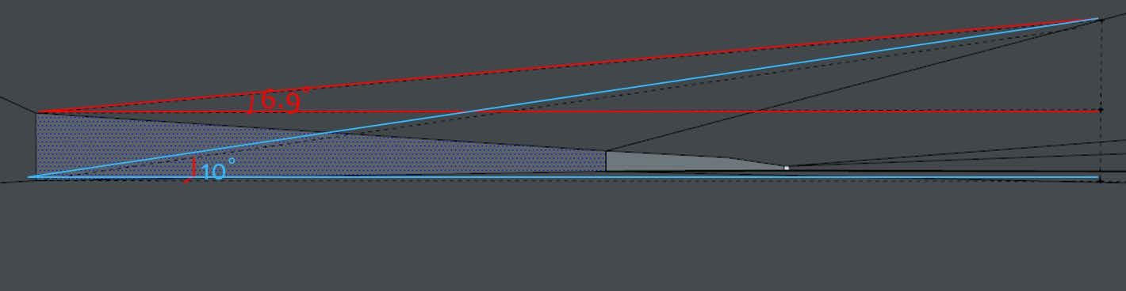

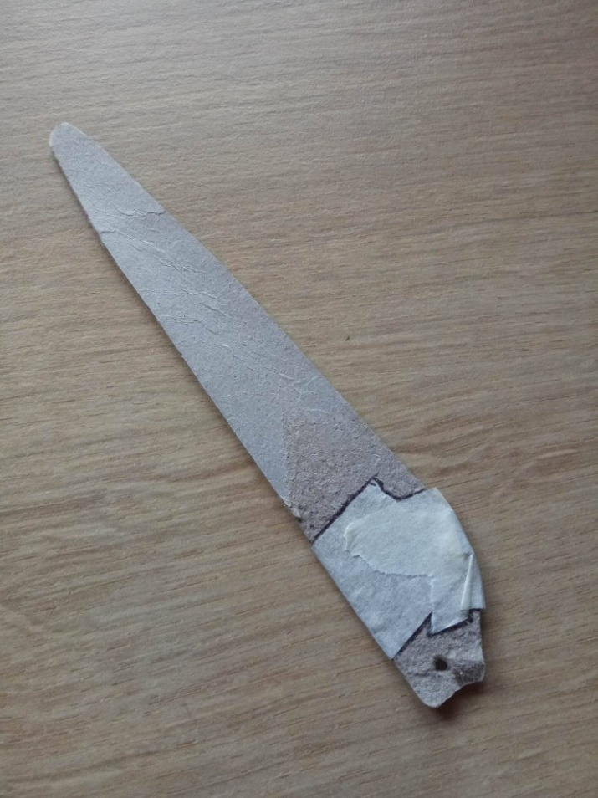*Figure 9.10 - Desired Pitch Angle vs. Modelled Pitch Angle*

*Figure 9.12 – Initial 3D printed blade design*

*Figure 9.11 – Initial cardboard blade design*

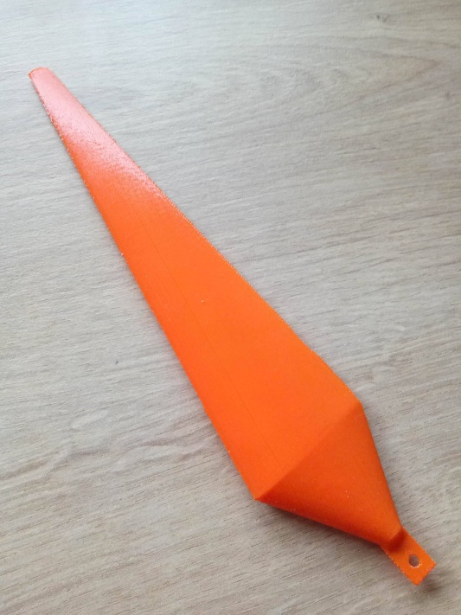

*Figure 9.13 – Final 3D printed blade design*



*Appendix 1.1 – Excel document of key results*

|  |  |  |  |  |  |  |  |  |  |  |  |  |
| --- | --- | --- | --- | --- | --- | --- | --- | --- | --- | --- | --- | --- |
| x | 1 | 1 | 0.99 | 0.97 | 0.95 | 0.93 | 0.9 | 0.87 | 0.84 | 0.8 | 0.75 | 0.71 |
| y | 0 | 0 | 0 | 0.01 | 0.02 | 0.03 | 0.03 | 0.04 | 0.05 | 0.06 | 0.06 | 0.07 |
|  |  |  |  |  |  |  |  |  |  |  |  |  |
| x | 0.66 | 0.62 | 0.57 | 0.52 | 0.47 | 0.42 | 0.37 | 0.33 | 0.28 | 0.24 | 0.2 | 0.17 |
| y | 0.08 | 0.08 | 0.09 | 0.1 | 0.1 | 0.1 | 0.1 | 0.1 | 0.1 | 0.1 | 0.09 | 0.08 |
|  |  |  |  |  |  |  |  |  |  |  |  |  |
| x | 0.13 | 0.1 | 0.07 | 0.05 | 0.03 | 0.02 | 0.01 | 0 | 0 | 0 | 0 | 0 |
| y | 0.08 | 0.07 | 0.06 | 0.05 | 0.04 | 0.03 | 0.01 | 0.01 | 0 | 0 | -0 | -0 |
|  |  |  |  |  |  |  |  |  |  |  |  |  |
| x | 0 | 0 | 0.01 | 0.02 | 0.04 | 0.06 | 0.08 | 0.11 | 0.15 | 0.19 | 0.22 | 0.26 |
| y | -0 | -0 | -0.01 | -0.02 | -0.02 | -0.03 | -0.04 | -0.04 | -0.05 | -0.06 | -0.07 | -0.07 |
|  |  |  |  |  |  |  |  |  |  |  |  |  |
| x | 0.3 | 0.34 | 0.38 | 0.43 | 0.48 | 0.54 | 0.6 | 0.65 | 0.71 | 0.77 | 0.82 | 0.86 |
| y | -0.07 | -0.06 | -0.06 | -0.05 | -0.03 | -0.02 | -0.01 | 0 | 0.01 | 0.01 | 0.02 | 0.02 |
|  |  |  |  |  |  |  |  |  |  |  |  |  |
| x | 0.91 | 0.94 | 0.97 | 0.99 | 1 | 1 |  |  |  |  |  |  |
| y | 0.02 | 0.01 | 0.01 | 0 | 0 | 0 |  |  |  |  |  |  |

*Appendix 1.2 – Specifications for turbine blade (S825 Airfoil Shape)*

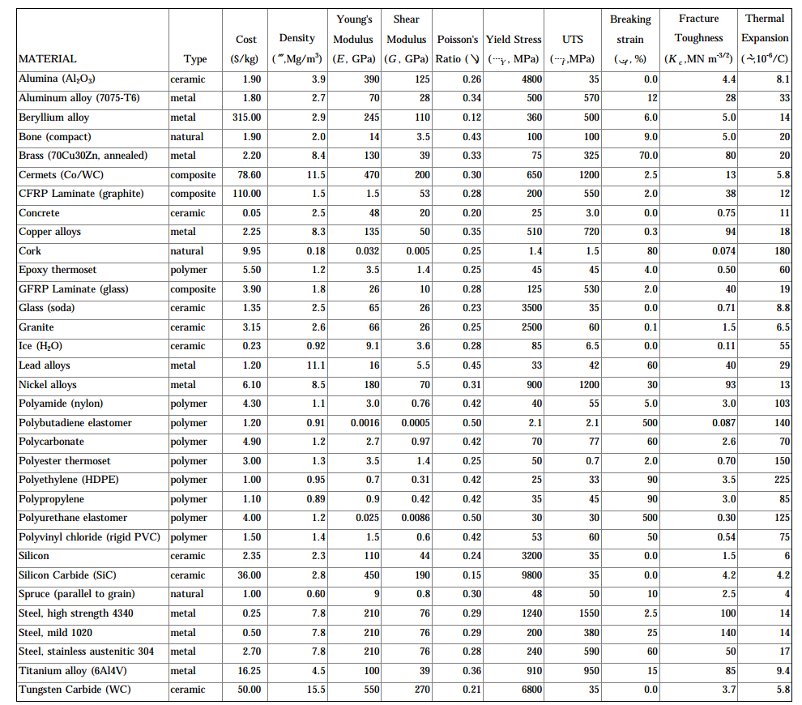

*Appendix 1.3 – “Props” PDF outlining costing and strengths of turbine materials (Props, 2003)*